South China University of Technology
《Course》Experiment Report
Experiment Title： The Design an Analysis of Computer Algorithms
Name： 张杰铖 Student ID： 202030443394
Class： 计科全英联合班 Group： Individual
Collaborator： NO
Teacher： 颜小洋
Description
【Objective and Requirement】
Objective：
How to use dynamic programming algorithm to solve the shortest path problem in graph theory and practice.
Requirement：
To solve the Shortest Path Problem by Dynamic Programming Algorithm (forward and backward)
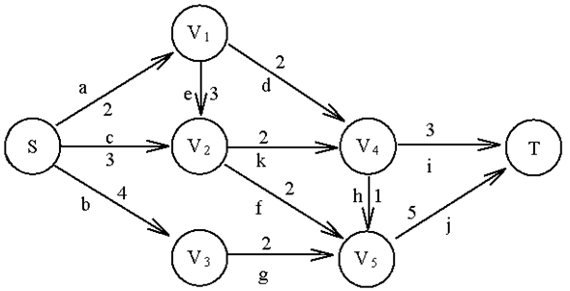
【Environment】
Operating System：Windows 10
Content
【Procedure】
- Step：
- First implement the Linked-List data structure, and then implement the Linked-List-based graph data structure.
- Implement forward dynamic programming algorithm and backward dynamic programming algorithm. The difference is that its state transition equation has a subtle difference between front-to-back and back-to-front. Since the Linked-List is one-way, the edges should be inserted into the Linked-List in reverse order when implementing backward.
2. Program：
#include <iostream>
#include <math.h>
#include <time.h>
#include <vector>
using namespace std;
#define NOTPATH 99999

template <class Elem> class listNode{
public:
Elem element;
listNode* next;
listNode(Elem& e,listNode* n=NULL){
element=e;
next=n;
}
listNode(listNode* n=NULL){
next=n;
}
};

template <class Elem> class Linked_list{
public:
listNode<Elem>* head;
listNode<Elem>* tail;
listNode<Elem>* fence;
int rightcnt,leftcnt;
Linked_list(){
head=tail=fence=new listNode<Elem>(NULL);
leftcnt=0;
rightcnt=1;
}
void clear(){
while(head!=tail) {
fence=head;
head = head->next;
delete fence;
}
rightcnt=leftcnt=0;
}
bool insert(Elem& e){
fence->next=new listNode<Elem>(e,fence->next);
if (fence==tail){
tail=fence->next;
}
rightcnt++;
return true;
}
bool append(Elem& e){
tail->next=new listNode<Elem>(e,tail->next);
tail=tail->next;
rightcnt++;
return true;
}
bool remove(Elem& it){
if(fence==tail){return false;}
listNode<Elem>* temp=fence->next;
fence->next=fence->next->next;
it=temp->element;
delete temp;
rightcnt--;
return true;
}
void setStart(){
fence=head;
rightcnt=leftcnt+rightcnt;
}
void setEnd(){
fence=tail;
leftcnt=leftcnt+rightcnt;
}
void prev(){
if(fence==head){return;}
listNode<Elem>* temp=head;
while(temp->next!=fence){
temp=temp->next;
}
fence=temp;
leftcnt--;
rightcnt++;
}
void next(){
if (fence==tail){return;}
fence= fence->next;
leftcnt++;
rightcnt--;
}
int leftLength(){
//左边的匣子数
return leftcnt;
}
int rightLength(){
return rightcnt;
}
bool setPos(int pos){
if(rightcnt+leftcnt<=pos){return false;}
fence=head;
rightcnt=leftcnt+rightcnt;
leftcnt=0;
while(pos--){
fence=fence->next;
leftcnt++;
rightcnt--;
}
return true;
}
bool getValue(Elem& it){
if(fence==tail){return false;}
it=fence->next->element;
return true;
}
void print(){
listNode<Elem>* temp=head;
cout<<"< ";
while(temp!=fence){
cout<<temp->next->element<<" ";
}
cout<<"| ";
while(temp!=tail){
cout<<temp->next->element<<" ";
}
cout<<">"<<endl;
}
};
class Graph{
public:
Linked_list<int>** graph;
int n;
int e;
int** Weight;
bool* Mark;

Graph(int tempn=7,int type=0){
n=tempn;
e =0;
graph=new Linked_list<int>*[n];
for(int i=0;i<n;i++){
graph[i]=new Linked_list<int>();
}
Weight=new int*[n];
for(int i=0;i<n;i++){
Weight[i]=new int[n];
for(int k=0;k<n;k++){
if(i==k){Weight[i][k]=0;}
else{Weight[i][k]=NOTPATH;}
}
}
Mark=new bool[n];
for(int i=0;i<n;i++){
Mark[i]= false;
}
if(type==0) {
setEdge(0, 1, 2);
setEdge(0, 2, 3);
setEdge(0, 3, 4);
setEdge(1, 2, 3);
setEdge(1, 4, 2);
setEdge(2, 4, 2);
setEdge(2, 5, 2);
setEdge(3, 5, 2);
setEdge(4, 5, 1);
setEdge(4, 6, 3);
setEdge(5, 6, 5);
}
if(type==1){
setEdge(1, 0, 2);
setEdge(2, 0, 3);
setEdge(3, 0, 4);
setEdge(2, 1, 3);
setEdge(4, 1, 2);
setEdge(4, 2, 2);
setEdge(5, 2, 2);
setEdge(5, 3, 2);
setEdge(5, 4, 1);
setEdge(6, 4, 3);
setEdge(6, 5, 5);
}

}
~Graph(){
delete Weight;
delete Mark;
delete graph;
}
int getn(){return n;}
int gete(){return e;}
int first(int a){
if(graph[a]->head==graph[a]->tail){return getn();}
graph[a]->setPos(0);
int result;
graph[a]->getValue(result);
return result;
}
int next(int a,int b){
graph[a]->setPos(0);
while(graph[a]->fence!=graph[a]->tail&&graph[a]->fence->next->element!=b) {
graph[a]->next();
}
if(graph[a]->fence==graph[a]->tail||graph[a]->fence->next==graph[a]->tail){return getn();}
graph[a]->next();
int result;
graph[a]->getValue(result);
return result;
}
void setEdge(int ver1,int ver2,int wei){
if(Weight[ver1][ver2]==NOTPATH){
graph[ver1]->append(ver2);
}
Weight[ver1][ver2]=wei;
e++;
// 有向图和无向图
// if(Weight[ver2][ver1]==NOTPATH){
// graph[ver2]->append(ver1);
// }
// Weight[ver2][ver1]=wei;
// //e++;
}
bool delEdge(int ver1,int ver2){
if(Weight[ver1][ver2]==NOTPATH){return false;}
graph[ver1]->setPos(0);
while (graph[ver1]->fence!=graph[ver1]->tail&&graph[ver1]->fence->next->element!=ver2){

}
if(graph[ver1]->fence->next==graph[ver1]->tail){return false;}
graph[ver1]->remove(ver2);
Weight[ver1][ver2]=NOTPATH;
e--;
// //有向图和无向图
// if(Weight[ver2][ver1]==NOTPATH){return false;}
// graph[ver2]->setPos(0);
// while (graph[ver2]->fence!=graph[ver2]->tail&&graph[ver2]->fence->next->element!=ver1){
//
// }
// if(graph[ver2]->fence->next==graph[ver2]->tail){return false;}
// graph[ver2]->remove(ver1);
// Weight[ver2][ver1]=NOTPATH;
// //e--;
return true;
}
int weight(int ver1,int ver2){
return Weight[ver1][ver2];
}
bool getMark(int ver){return Mark[ver];}
void setMark(int ver,bool flag=true){
Mark[ver]=flag;
}
};
struct Dynamic{
int m;
vector<int> D_Path;
};

Dynamic F_minPath(int node){
Dynamic d;
if(node==6){d.D_Path.push_back(6);d.m=0;return d;}
int m=99999;
for (int w=global_g->first(node);w<global_g->getn();w=global_g->next(node,w)){
Dynamic temp_d= F_minPath(w);
if(m>(temp_d.m+global_g->weight(node,w))){
d.D_Path.clear();
d.D_Path.assign(temp_d.D_Path.begin(),temp_d.D_Path.end());
m=temp_d.m+global_g->weight(node,w);
}
}
d.D_Path.push_back(node);
d.m=m;
return d;
}

Graph* global_g2=new Graph(7,1);

Dynamic B_minPath(int node){
Dynamic d;
if(node==0){d.D_Path.push_back(0);d.m=0;return d;}
int m=99999;
for (int w=global_g2->first(node);w<global_g2->getn();w=global_g2->next(node,w)){
Dynamic temp_d= B_minPath(w);
if(m>(temp_d.m+global_g2->weight(node,w))){
d.D_Path.clear();
d.D_Path.assign(temp_d.D_Path.begin(),temp_d.D_Path.end());
m=temp_d.m+global_g2->weight(node,w);
}
}
d.D_Path.push_back(node);
d.m=m;
return d;
}

int main(){
Dynamic F;
beginTime=clock();
F=F_minPath(0);
endTime=clock();
cout<<F.m<<endl;
for (int i=0;i<F.D_Path.size();i++){
cout<<F.D_Path[F.D_Path.size()-1-i]<<" ";
}
cout<<endl<<"Forward Dynamic Programming-Time using: "<<(double)((endTime-beginTime)/CLOCKS_PER_SEC)<<endl;

Dynamic B;
beginTime=clock();
B=B_minPath(6);
endTime=clock();
cout<<B.m<<endl;
for (int i=0;i<B.D_Path.size();i++){
cout<<B.D_Path[i]<<" ";
}
cout<<endl<<"Backward Dynamic Programming-Time using: "<<(double)((endTime-beginTime)/CLOCKS_PER_SEC)<<endl;

}
3. Result：
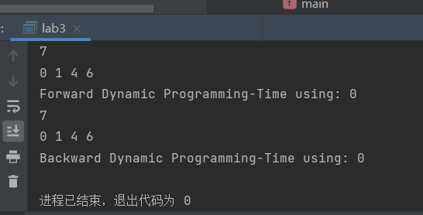
Conclusion
Dynamic programming is an optimal algorithm implemented by using state transition equations. It uses recursion cleverly, and the code size is smaller and more subtle than the tree search algorithm.
Teacher’s Comments and Score
Comment：

Score： Signature：
Date：

